**Jobsheet 02 Class dan Object**

Erwan Majid/08/2i

Link github: <https://github.com/Majid5654/Semester-3/tree/Main/JAVA%20OOP/Week2>

**4. Experiment**

4.1 Experimental 1: Creating Class Diagram

Case study 1:

In a company, one of the data that is processed is employee data. Each employee

has an id, name, gender, title, title and salary. Each employee can also view personal data

and see his salary.

1. Describe the class diagram design from case study 1 !,

-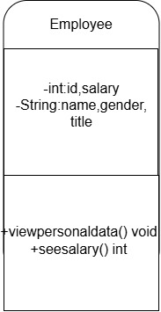

2. Mention what classes can be made from case study 1 !,

-Employee

3. Mention the attributes and data types that can be identified from

each class from case study 1!

- id: int – Unique identifier for each employee.

name: String – Employee's full name.

gender: String – Gender of the employee

title: String – Job title of the employee.

salary: int – Employee's salary.

4. Mention the methods that you created from each class in case study 1!

-public int viewSalary() {

return (int) salary;

}

public void viewPersonalData() {

System.out.println("ID: " + id);

System.out.println("Name: " + name);

System.out.println("Gender: " + gender);

System.out.println("Title: " + title);

}

**4.2 Experimental 2: Create and accessing the member of a class**

Case Study 2:

Class Mahasiswa:

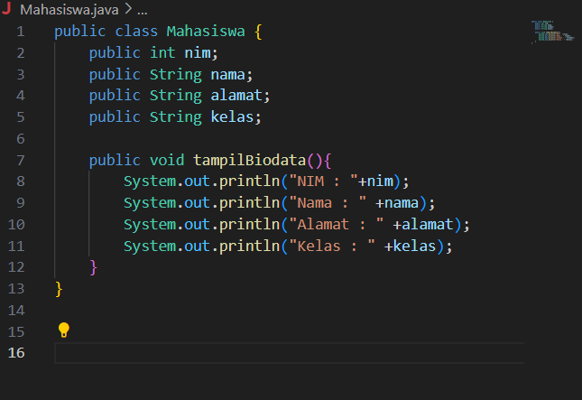

Class TestMahasiswa:

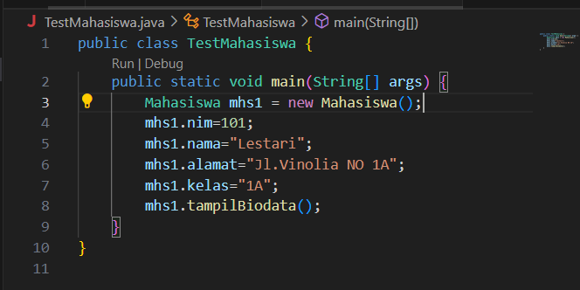

6. Run the TestMahasiswa class

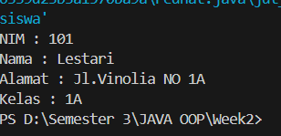

7. Based on the code, please explain in which line the attribute declaration was?- in the Mahasiswa class

Lines 2 until 5

public int nim;

public String nama;

public String alamat;

public String kelas;

8. Based on the code, please explain in which line the method declaration was?

- in the Mahasiswa class on line 7

public void tampilBiodata()

9. How many objects instantiate from the code?

-only one object which is Mhs1

Mahasiswa mhs1 = new Mahasiswa();

10. What does this line “mhs1.nim=101” mean?

-this mean the attribute nim of the object mhs1 is being assigned the value 101

11. What does this line “mhs1.tampilBiodata()” do?- calls the tampilBiodata() method of the mhs1 object. This method prints the values of the attributes nim, nama, alamat, and kelas for the mhs1 object.

12. Please instantiate 2 more object, by adding more code

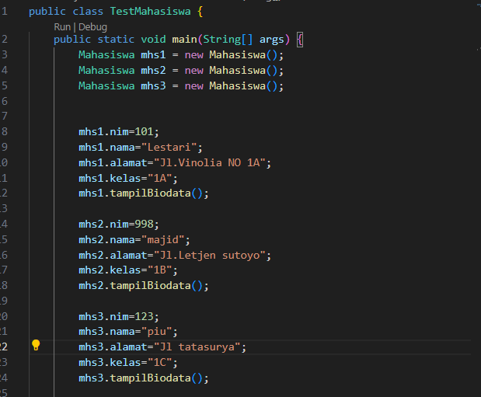

- 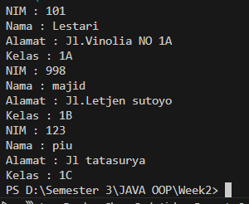

* **Experimental 3: Writing method that has a return value**

-Class barang:

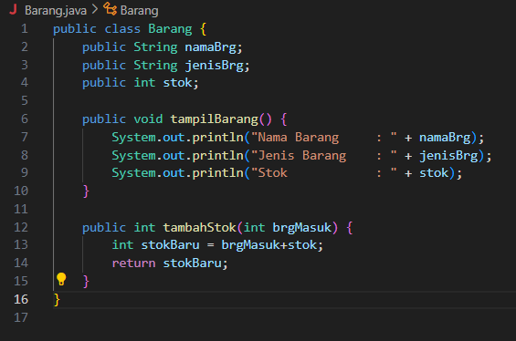

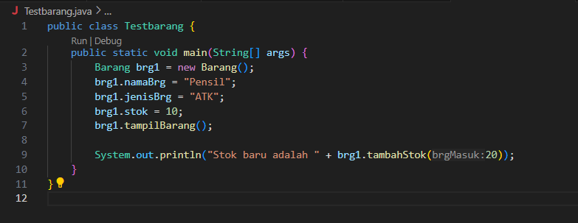-class testbarang:

3. Run the code!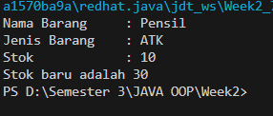

4. What is the function of an argument in a method?

- the function of the argument is to allow the method to receive input data from the outside, which can then be used in the method's calculations or operations

In the code :

public int tambahStok(int brgMasuk) {

int stokBaru = brgMasuk + stok;

return stokBaru;

}

The argument brgMasuk is passed to the method when it is called

brg1.tambahStok(20);

5. Makes conclusion on “return” keyword, when should we used it?

- For non-void methods:

Return a value: When a method has a return type (e.g., int, String), it must use return to return a value that matches the method's return type.

- for void methods:

Exit the method early: Use return to stop method execution prematurely when no value is returned.

4.2 Assignments

1. One of the video game rental shops process is borrowing, The stored data when

someone renting the game are the id, member name, game name, and the amount to

pay. Each rent can display the data and the amount to pay. Make a class diagram based

on the case study!

explanation:

• The price amount will be coming from price per day times renting duration!

• Assume that 1 transaction will only consist of 1 game.

-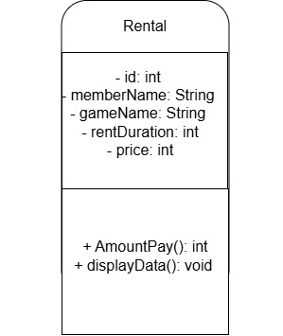

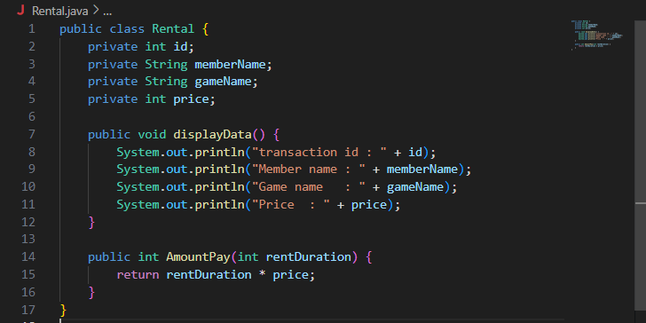2. Create the code based on the case study no 1!

3. More exercise, please create the code from the following class diagram

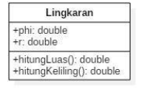

-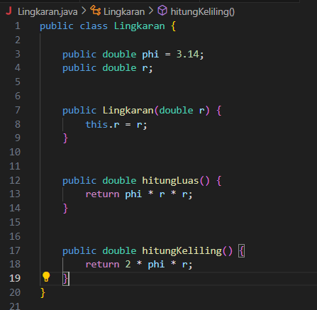

4. More exercise, please create the code from the following class diagram:

